International Fitness & Bodybuilding Federation
Dublin 39/I – Europolis – Las Rozas - Madrid – 28232 – Spain - Tel: (34) 5352819
E-mail: headquarters@ifbb.com Website: www.ifbb.com

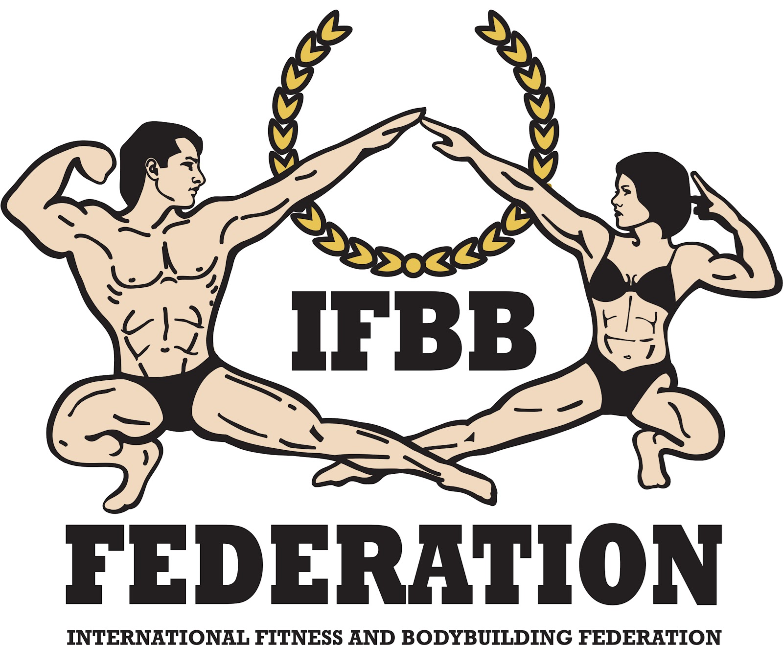

FINAL ENTRY FORM

2026 IFBB WORLD FITNESS GAMES
August 29th - 31st, 2026
ISTANBUL – TURKEY
IFBB PRO QUALIFIER; IFBB RANKING EVENT LEVEL 3
Deadline to send this Final Entry Form is Monday, August 17th, 2026
It is full responsibility and obligation of the National Federation to verify if each one of the athletes to be registered on this international event are NOT SUSPENDED or fulfilling any period of ineligibility due to Anti-Doping Rule Violation or any disciplinary case at national or international level.

COUNTRY |  | NATIONAL FEDERATION’S NAME |  |  |  | NF PRESIDENT’S NAME
 |  |  |  |  |  | Mr./Ms.
FEDERATION’S CONTACT NO. (OFFICE OR CELL PHONE) |  |  |  | NATIONAL FEDERATION’S E-MAIL ADDRESS
 | If applicable: Responsible Delegate(s) name at this event |  |  |  | Cell phone |  | PASSPORT No.
1  2 | Mr./Ms.  Mr./Ms.
Complete this Form in English Letters and leave it in the WORD format, so we can copy/paste the athletes’ names on our list. DO NOT change it to PDF format, please.
 | Competitor’s  1 Given NAME + 1 Family NAME |  | EXACT CATEGORY  (from the list of available categories below) |  |  |  | IFBB IC or  PASSPORT No.
1
2
3
4
5
6
7
8
9
10
11
12
13
14
15
16
17
18
19
20
21
22
23
24
25

IF YOU HAVE MORE ATHLETES, CONTINUE THIS TABLE, PLEASE.

IMPORTANT NOTES:
ALL THE COSTS FOR TRAVELLING, HOTEL ACCOMMODATIONS AND MEALS (AND TRANSPORT FROM AND TO THE AIRPORT) MUST BE COVERED BY NATIONAL FEDERATIONS. HOTEL RESERVATION MUST BE DONE BY DIRECT COMMUNICATION BETWEEN THE NATIONAL FEDERATION AND THE HOTELS. RECOMMENDED HOTELS: NOVA OTEL , IBIS OTEL, WOW ISTANBUL HOTEL. CHECK WITH YOUR NATIONAL FEDERATION FOR MORE INFORMATION.

This Final Entry Form will only be considered if it is sent by the National Federation of the athlete and directly to the Organizing Committee, IFBB Head Office in Madrid and IFBB Technical Committee (see e-mail addresses below). The final decision to allow an athlete to compete in this event rests with the IFBB.

Registration Fee for athletes is EUR €250 to be paid not later than Tuesday, August 18th, 2026 midnight (CEST = UTC +2). If paid after August 18th, 2026, it will be EUR €300.
Fees have to be paid online on the IFBB webpage: http://www.ifbb.com/competition-registration. Please add your
name during online payment and bring a copy of your payment confirmation to the registration.
IFBB Athlete’s International License (Blue Book) annual fee is EUR €40 (if unpaid).

Crossovers: an extra fee of EUR €100 per each of the additional categories will be charged.
Possible crossovers: Games Classic Bodybuilding - Classic Bodybuilding – Classic Physique – Bodybuilding; Women’s Acrobatic Fitness – Women’s Bodyfitness; Women’s Artistic Fitness – Women’s Bikini – Women’s Fit-Model, Women’s Wellness – Women’s Fit-Model. Also junior and masters in senior classes.

Please list your IFBB INTERNATIONAL JUDGES coming to this event:
 | NAME OF JUDGE(S) - (AS WRITTEN IN PASSPORT) | PASSPORT NUMBER
1 | Mr./Ms.
2 | Mr./Ms.
3 | Mr./Ms.
4 | Mr./Ms.

Please list your TEST- JUDGES names here:
 | NAME OF TEST- JUDGE(S) - (AS WRITTEN IN PASSPORT) | PASSPORT NUMBER
1 | Mr./Ms.
2 | Mr./Ms.
3 | Mr./Ms.
4 | Mr./Ms.

CATEGORIES OPEN AT THE 2026 IFBB WORLD FITNESS GAMES
Men’s Bodybuilding  Up to & incl. 70 kg  Up to & incl. 80 kg  Up to & incl. 90 kg  Over 90 kg  OVERALL (IFBB Pro Cards for the top 3)  Junior Men’s Bodybuilding 15-23 yrs - OPEN  Men’s Games Classic Bodybuilding*  Up to & incl. 175 cm  Over 175 cm  OVERALL  Men’s Classic Bodybuilding*  Up to & incl. 171 cm  Up to & incl. 175 cm  Up to & incl. 180 cm  Over 180 cm  OVERALL (IFBB Pro Cards for the top 3)  Junior Men’s Classic Bodybuilding* 15-23 yrs - OPEN  Junior Men’s Classic Physique* 15-23 yrs - OPEN  Men’s Physique  Up to & incl. 170 cm  Up to & incl. 173 cm  Up to & incl. 176 cm  Up to & incl. 179 cm  Up to & incl. 182 cm  Over 182 cm  OVERALL (IFBB Pro Cards for the top 3)  Junior Men’s Physique  15-20 years: open  21-23 years: open  OVERALL  Men’s Fit Model - OPEN  Fit-Pairs | Women’s Acrobatic Fitness - OPEN  Women’s Artistic Fitness - OPEN  Women’s Bodyfitness  Up to & incl. 163 cm  Over 163 cm  OVERALL (IFBB Pro Cards for the top 2)  Junior Women’s Bodyfitness 15-23 years - OPEN  Women’s Bikini  Up to & incl. 160 cm  Up to & incl. 162 cm  Up to & incl. 164 cm  Up to & incl. 166 cm  Up to & incl. 169 cm  Up to & incl. 172 cm  Over 172 cm  OVERALL (IFBB Pro Cards for the top 3)  Junior Women’s Bikini 15-23 yrs  16-20 years: open  21-23 years: open  OVERALL  Women’s Wellness  Up to & incl. 163 cm  Over 163 cm  OVERALL (IFBB Pro Cards for the top 2)  Junior Women’s Wellness 15-23 years - OPEN  Women’s Fit-Model  Up to & incl. 162 cm  Up to & incl. 168 cm  Over 168 cm  OVERALL  Junior Women’s Fit-Model 15-23 yrs - OPEN  Masters Women’s Fit-Model >35 yrs - OPEN

Note 1: A category will only be run if 3 or more athletes are registered. Otherwise, categories will be combined.
Note 2: * - Categories with weight / height limits

FITNESS CHALLENGE:
Individual Categories:
- GOLD MEN / WOMEN INDIVIDUAL (SENIOR)
- SILVER MEN / WOMEN INDIVIDUAL (SENIOR)
- BRONZE MEN / WOMEN (SENIOR)
- INDIVIDUAL SPEED FIT (10 REPS/3 EXERCISES – DEVIL PRESS – PULL UPS – LUNGES)
Couples (Paired) Categories:
GOLD / SILVER MIXED COUPLES

EXTRA DELEGATES AND SUPPORTERS
 | Extra Delegates or Supporters | If a Judge please  V |  | Extra Delegates or Supporters | If Judge please  V
1 |  |  | 11
2 |  |  | 12
3 |  |  | 13
4 |  |  | 14
5 |  |  | 15
6 |  |  | 16
7 |  |  | 17
8 |  |  | 18
9 |  |  | 19
10 |  |  | 20

Please send this Entry Form no later than Monday, August 23rd, 2024 to:  Organizing Committee  Mr. Koray Girgin  E-mail: info@tvgfbf.gov.tr  and koraygirgin@gamil.com  IFBB Technical Committee  Eng. Andrew Michalak  E-mail: amichalak5@gmail.com | Please send a copy to:  International Fitness & Bodybuilding Federation  Head Office:  Ms. Daria  E-mail: contact@ifbb.com

Date of issue:

Completed by (your name & position in the NF):

